Git Back-End Report #1: Setting up AWS

For the back-end system, I have chosen to store the database in a AWS virtual machine. The university advised using an Azure virtual machine but there were problems with the university network blocking certain packets and being unable to access the VM from outside the university network. I therefore decided that using an AWS VM was the best option.

I am going to use docker as suggested and then have a mysql database created inside of that. I first tried to make a windows VM with AWS but then experienced problems with docker. Docker uses a Linux VM itself to run so when I tried to run it in the windows VM AWS returned errors and stopped running due to having a VM inside of a VM; I therefore had to use a Linux VM instead.

I created this instance:

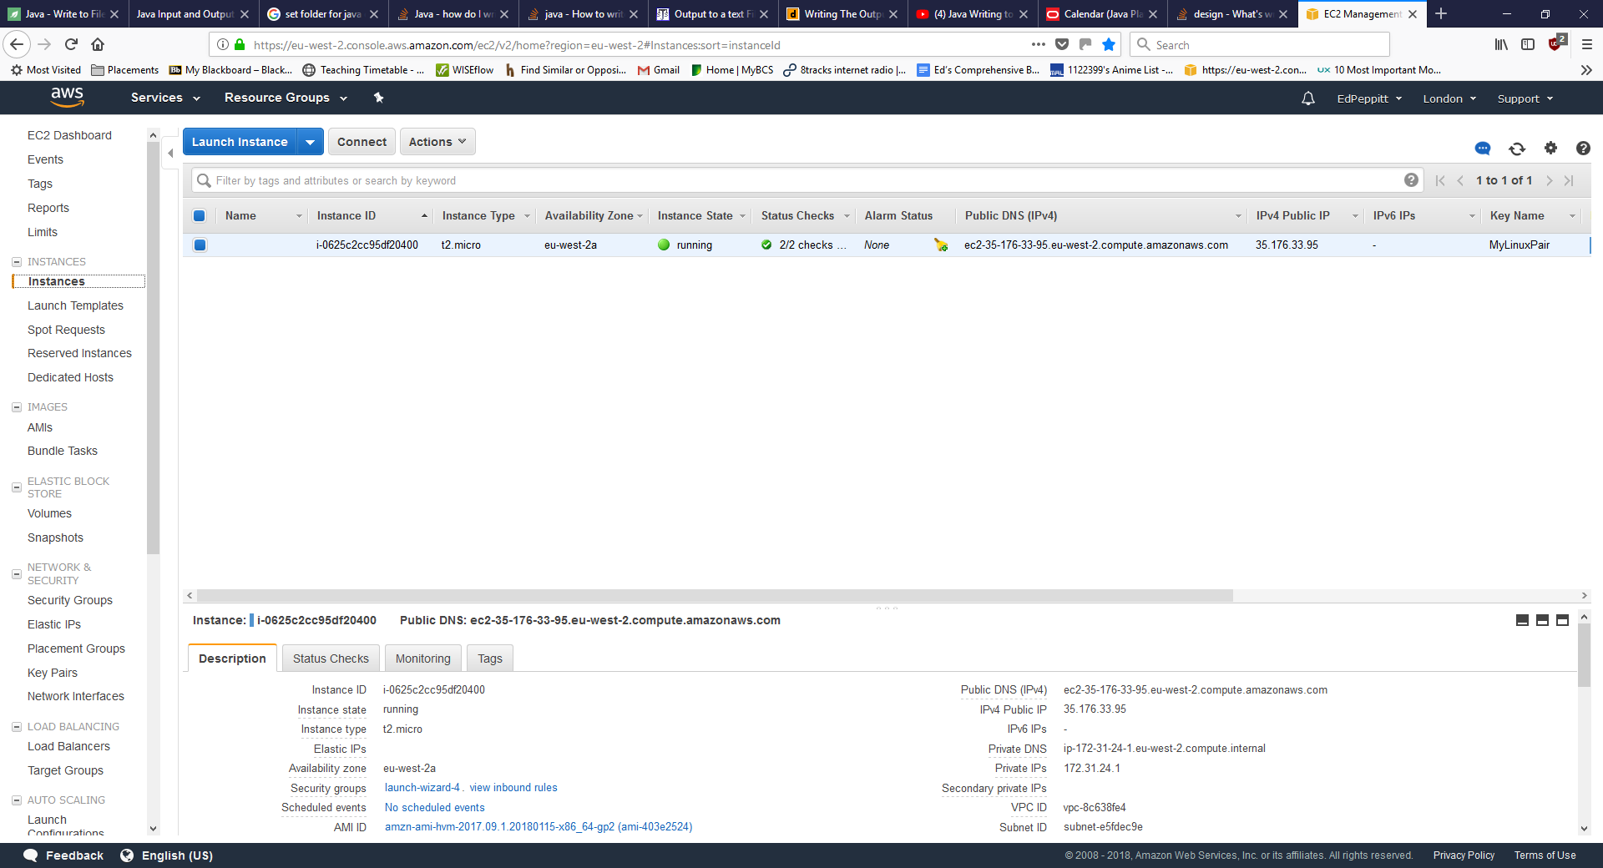

In order to access the AWS VM I had to set up a ssh client using PuTTY. I followed the instructions on this: <https://docs.aws.amazon.com/AWSEC2/latest/UserGuide/putty.html> website to create a connection to my Linux VM.

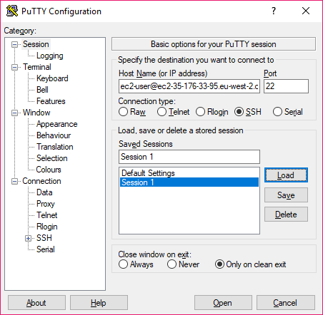

This is my PuTTY Configuration

And opens up this console:

